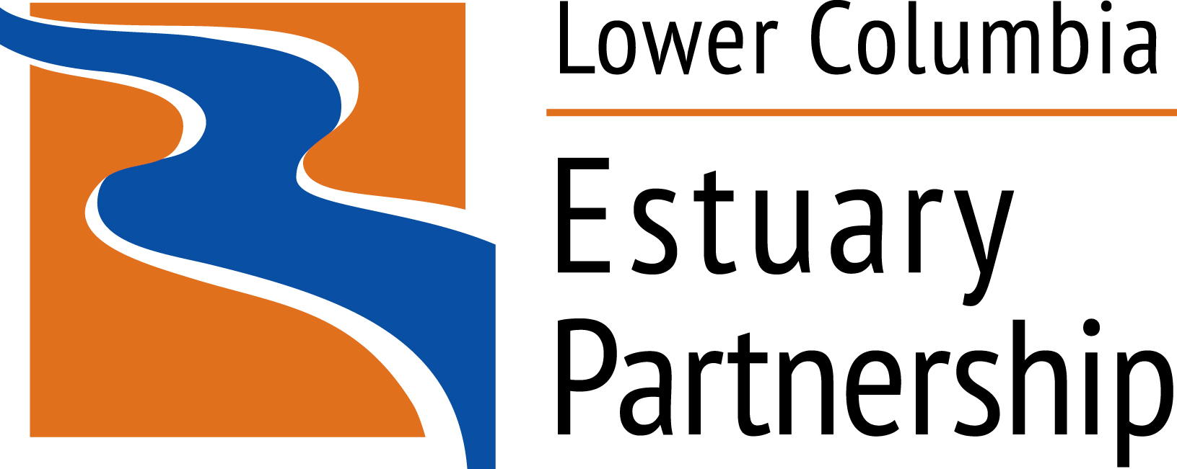

Habitat Restoration Technical Assistance Project Funding

The Estuary Partnership manages a Habitat Restoration Program for the lower Columbia River and estuary. The Estuary Partnership has identified that the most successful habitat restoration projects are those that have well thought out designs and fully articulated scopes. To help bring large, complex or otherwise preliminary phase projects closer to these goals, the Estuary Partnership has developed a Technical Assistance Project Funding program. Funding is intended to provide the upfront resources and technical assistance necessary for developing habitat restoration projects up to a 30% design level.

This program is funded through an award with the Bonneville Power Administration to help develop, design, and implement larger and more complex projects. Funds may be used to initiate concept designs, collect baseline data, access engineering, hydrology, geotechnical expertise, or for other technical purposes.

Application Process
There is no deadline for application submittals. Applications will be considered on a first come, first serve basis until funds are depleted. Decisions are likely to be made on individual applications within four weeks from the date of submission.

Applicants requesting technical assistance should complete the Technical Assistance Application form and return it via email to Tom Argent, the Estuary Partnership’s Finance Manager (targent@estuarypartnership.org; telephone 503.226.1565, ext. 242). For more information, to discuss project ideas, or to ask questions about the application process, please contact Daniel Evans via e-mail (devans@estuarypartnership.org) or by telephone at 503.226.1565, ext. 238.

Funding Request Guidance
The Estuary Partnership anticipates up to $200,000 will be available yearly for funding multiple projects. Awards are not expected to be greater than $70,000 per project. To be considered for funding, all projects must be within tidally influenced areas of the lower Columbia River and its tributaries and be consistent with the Estuary Partnership Management Plan (http://www.estuarypartnership.org/sites/default/files/CCMP%20Action%20Update%20Final%200212.pdf).

Application Evaluation Process
Applications will be evaluated against the following criteria:
- the applicant’s management goals for the site;
- consistency with the Estuary Partnership’s Management Plan, 2008 Federal Columbia River Power System Biological Opinion, state recovery plans and other regional plans;
- potential to increase juvenile ESA listed salmonid access or opportunity to rearing and refuge habitat;
- potential to increase the capacity or quality of juvenile salmonid habitat;
- likelihood of further restoration project implementation and success;
- the number of ESA listed salmonid species expected to use the restoration site; and
- the size and cost of the project.

Applications may score higher if the restoration projects resulting from the technical assistance are:
- large in size;
- will result in high connectivity between the site and the Columbia River;
- will provide access to multiple species of ESA listed salmonids during a majority of the year; and
- will result in a relatively large degree of complexity (i.e., channel networks, presence of large wood.).

Habitat Restoration Technical Assistance Project Application

1. Project/Site Title

2. Applicant Name

3. Applicant Staff Contact
Name/Title:
Address:
Telephone Number:
Email:

4. Type of Assistance Requested (select multiple if applicable):
Baseline data collection
Scoping
Conceptual design
Engineering
Geotechnical
Other (specify):

5. Location
Latitude (decimal degrees):
Longitude (decimal degrees):

Specific description of the project’s location and property ownership:

6. Timeline for Technical Assistance
Anticipated Length:
Requested Start Date:
Requested Completion Date:
Identify any existing or potential circumstances or considerations that may impact the anticipated timeline of the technical assistance project.

7. Funding Request for Technical Assistance
Total Cost: $__________
Estuary Partnership Share: $__________
Applicant's Share* $__________
*Cost share is not required. However, applicants are encouraged to demonstrate partnerships, in-kind support, staff time, and/or any funds they will be contributing to this project.

Cost share details/partners (if applicable):
8. Narrative
Please include the following information in your application. The information will be the basis for evaluating funding for applications. This section shall not exceed two double-sided pages; single spaced, using no less then one inch margins and 11 pt. font.

- Describe the site and where it is located in the lower Columbia River and estuary. Provide information on the site’s current habitat conditions and your goals for developing projects at the site. Provide a description of the problems at the site you anticipate addressing and any anticipated methods to be used.

- Describe the technical assistance needed and why it is necessary. If a specific restoration action has already been identified, please describe it and how the technical assistance forwards the implementation of the project. Please include the size of the project and what restoration elements will be part of the project.

- Provide details on any anticipated challenges associated with the technical assistance project and any unique skill sets or experience that may be required. Are there any deadlines or scheduling constraints? Describe any immediate next steps.

- Identify the salmonid species that currently use the site and how they may be affected by the restoration project(s). Specify which salmonid Evolutionarily Significant Units (ESUs) may benefit from restoration project(s) resulting from this technical assistance. How will the project increase juvenile salmonids’ access to the site or increase the capacity and quality of the site?

- Have pre-project or baseline monitoring data been collected at the site? Describe the type of data collected and any monitoring results. Describe preliminary designs or modeling that has been completed for the project(s).

9. Maps
Include project map(s) and photos of the project site, in JPEG format. If inter-tidal reconnection is a potential goal for the site, please include a map of estimated average maximum extent of inundation and how this extent was calculated. Please state if this estimate reflects daily tidal or seasonal inundation.

10. Relationship to Existing Programs
Describe how your goals for the site are consistent with and will implement aspects of the Lower Columbia River Estuary Partnership’s Management Plan (http://www.estuarypartnership.org/sites/default/files/CCMP%20Action%20Update%20Final%200212.pdf) and other plans, including the Lower Columbia Fish Recovery Board’s Lower Columbia Salmon Recovery and Fish & Wildlife Subbasin Plan, Oregon Department of Fish and Wildlife’s draft Lower Columbia River Conservation and Recovery Plan for Oregon Populations of Salmon and Steelhead, NOAA Fisheries draft 2008 Biological Opinion for the Federal Columbia River Power System, NOAA Fisheries Columbia River Estuary ESA Recovery Plan Module for Salmon and Steelhead and An Ecosystem-Based Approach to Habitat Restoration Projects with Emphasis on Salmonids in the Columbia River Estuary (Johnson et al., 2003).

11. Management
Who will manage the technical assistance from your end and ensure successful completion of the project? What is their experience in similar projects?

12. Authorized Signatory
I certify to the best of my knowledge that the information in this application is true and correct and that I am legally authorized to submit this information on behalf of the applicant.

Printed Name | Signature
Title | Date

Please submit the completed application to Finance Manager Tom Argent
targent@estuarypartnership.org
Tel: 503.226.1565 ext 242

For more information, to discuss project ideas, or to ask questions about the application process, contact:
Estuary Partnership Restoration Ecologist Daniel Evans
devans@estuarypartnership.org
503.226.1565 ext. 238

Lower Columbia Estuary Partnership
811 SW Naito Parkway, Suite 410
Portland, OR 97204
www.estuarypartnership.org

