Plot Sampling and Estimating Bug Populations

GRADES: 3-6
TIME: ~30 minutes

In this activity students discover the bug communities on the ground in their schoolyard or local natural area using real-world, field-based science methods. This activity lends itself to scientific inquiry and data collection and is a simple way to get students engaging with nature and learning outside the classroom.
MATERIALS:
- Measuring tape
- Calculator(s)
- 1x1 foot cardboard or poster board frame (could also use hula hoops or lengths of rope to form a frame)
- Magnifying glasses or jeweler’s loupes

LEARNING OBJECTIVES:
- Students will estimate the number of bugs on the ground in an area of the school yard
- Students will discover insect species or types
- Students will understand how to use sample plots to estimate larger areas

VOCABULARY: area, estimate, plot sampling, average, invertebrate

INTRODUCTION AND BACKGROUND DISCUSSION:
- “Bug” is a catchall name for small invertebrate organisms such as insects, spiders, millipedes, centipedes, slugs, snails, and flies, etc. Bugs can be found everywhere and often in surprising places. They are a crucial part of the food chain and exist in all habitats - even in cities.
- Have students guess how many bugs might live on the ground in their school yard. Explain that it would be nearly impossible to count every bug in the yard. How do scientists count bugs? Introduce estimation methods.
- Determine the size of the area to be plot samples: designate a rectangular area of grass or garden that can easily be measured. Use a measuring tape or use the ruler tool in google earth to find length and width. If the area is an odd shape, use google earth to create a polygon and copy and paste polygon folder into earthpoint.us/Shapes.aspx.

BUG HUNT (15-20 MIN.):
- Equip each student or pair of students a 1x1 foot square cardboard frame. Have students spread out across the designated study area and place the frame on the ground. For 2 minutes, students will observe and count everything that moves within the frame. Students will record data on the frame or in a nature journal. Students can repeat the process multiple times in different locations within the designated area.

CALCULATIONS: (5-10 MIN.)
- Inside, have students share their bug count findings with the class and use the class count totals to calculate an average.
- Area – how many sample squares would be needed to fill the whole study area? Have students calculate the total study area by multiplying the width by the length. Transparent graph paper can help illustrate.
- Estimate the total number of bugs in the sample area as follows:
(Average # bugs per square foot sample) X (total area)

For example, if there was an average of 36 bugs for every square foot and the total sample area was 300 square feet, we would estimate there is a total of 10,800 bugs!

EXTENSION IDEAS:
Inquiry Projects: Where do you find the most bugs? Consider variables such as:
- Substrate type: grass, mulch, dirt, leaves, garden bed
- Time of year or time of day
- Weather
- Sunny vs. shady locations
- Disturbances such as the amount of foot traffic, mowing, noise etc.

RESOURCES:
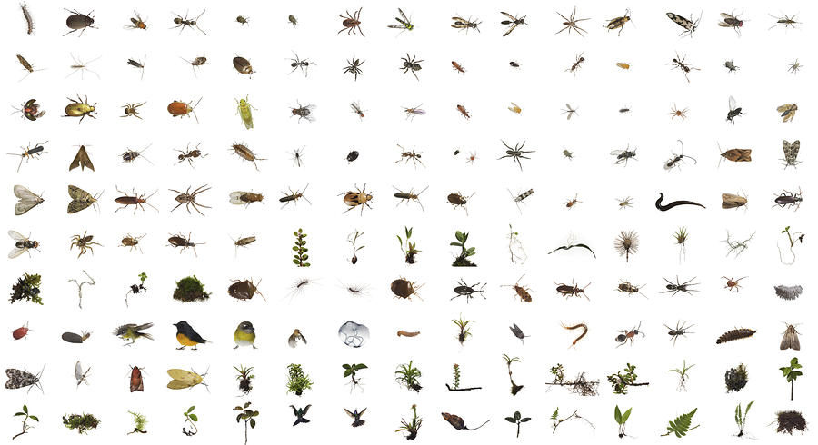
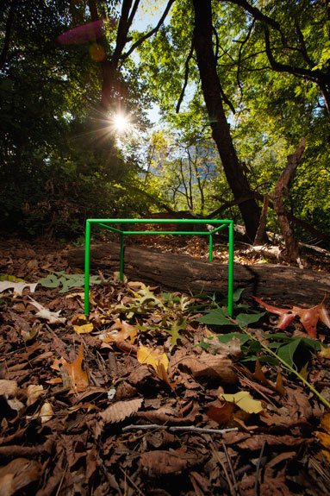
Check out the amazing photographs and article from National Geographic on the biodiversity of life that can be found in one cubic foot of the world. http://ngm.nationalgeographic.com/2010/02/cubic-foot/wilson-text

