

Habitat Restoration Design and Implementation Project Application

This application is adapted from the Expert Regional Technical Group’s (ERTG) project review template and includes several modifications necessary to satisfy the Estuary Partnership’s project review process. Habitat restoration project applications will be reviewed against the Estuary Partnership’s project review criteria and may be reviewed against some of the ERTG project review criteria. The review process is described in greater detail in Section 2 (Project Narrative) of this application.

SECTION 1: BACKGROUND AND PROJECT DESCRIPTION

1. PROJECT INFORMATION
Project Title:
Project Type:  Construction  Acquisition  Design / Planning

2. APPLICANT CONTACT INFORMATION
Organization:
Project Manager/Title:
Address:
Telephone Number: Email:
Fiscal Agent:

3. PROJECT LOCATION
Latitude, Longitude (e.g., -123.45, 45.67):
HUC 5 Watershed Name and Code (10-digit hydrologic unit code):
County/State:
Columbia River Mile:
River or Stream Name:
Distance from mainstem Columbia River (in river miles):
Landowner(s)
 Public: Agency:
 Private: Name(s):

4. PROPOSED PROJECT SCHEDULE
Provide a list of major tasks to be completed as part of this project, start and end dates for each task, and a description of the task.

Project Task | Start Date | End Date | Task Description

5. PROJECT COST
Total Project Cost: $__________
Estuary Partnership Share: $__________
Applicant's Share: $__________
Cost-share is not required for this funding opportunity.

6. PROJECT PARTNERS
List all anticipated funding sources and indicate the dollar value of their cash or in-kind contributions. Mark the respective box to show if contributions have been secured or are pending.

Project Partner | Cash | In-Kind | Secured | Pending

7. PROJECT SUMMARY
Provide a 250-word summary of the project, including the following: project type (i.e., design, restoration, acquisition); project description; number of acres or miles treated; habitat function(s) being restored; benefit to salmon; timeline; and partners.

Note which of the 13 ESA listed salmon Evolutionarily Significant Units (ESUs) or steelhead Distinct Population Segments (DPSs) found in the Columbia River will benefit from the project:

 | Chinook Salmon (Oncorhynchus tshawytscha): |  | Steelhead (Oncorhynchus mykiss):
 | Snake River spring/summer Chinook salmon |  | Snake River steelhead
 | Snake River fall Chinook salmon |  | Upper Columbia River steelhead
 | Upper Columbia River spring Chinook salmon |  | Middle Columbia River steelhead
 | Upper Willamette River Chinook salmon |  | Lower Columbia River steelhead
 | Lower Columbia River Chinook salmon |  | Upper Willamette River steelhead
 | Chum salmon (Oncorhynchus keta)  Columbia River chum salmon |  | Sockeye salmon (Oncorhynchus nerka)  Snake River sockeye salmon
Coho salmon (Oncorhynchus kisutch)
Lower Columbia River coho salmon

The StreamNet Mapper can be used together to facilitate identification of reaches with listed species (http://www.streamnet.org/data/interactive-maps-and-gis-data/).
If ESU information is unavailable, specify if ocean-type or stream-type salmonids will benefit from project.

8. AUTHORIZED SIGNATORY
I certify to the best of my knowledge that the information in this application is true and correct and that I am legally authorized to submit this information on behalf of the applicant.

Printed Name | Signature
Title | Date

SECTION 2: PROJECT NARRATIVE

Please answer the following questions. Embed appropriate maps and photographs with each response. The responses to these questions will be the basis for evaluating and ranking project proposals. Text shall be single spaced, with no less than one inch margins and 11-point font. Refer to the following online resources: 1) ERTG Resources documents (ERTG Landscape Principles (#2017-02), ERTG Scoring Criteria (#2020-02)); 2) Estuary Partnership project review criteria, and the definitions below (footnotes) when completing the project narrative.

For multi-phased projects focus content for each section below on what this proposed phase specifically addresses. While information and maps incorporating all phases provides useful context to understand a proposed phase; maps, performance metrics, and text should focus primarily on what the proposed phase will accomplish, and secondarily on what it may accomplish should other phases be constructed.

Project Information:
Project name |  | Project name
Date |  | Date the template was prepared
Prepared by |  | Name, phone number, and email address
Sponsoring agency |  | Contact name, phone number, and email address
Funding agency |  | Contact name, phone number, and email address
Site |  | Site location, river, river mile, latitude/longitude
Project status or stage |  | Status or stage of the proposed project
Project Description:
Problem statement |  | Summarize the site-specific problem(s) the proposed restoration(s) is intended to address. What are the causes of the problems?
Vision/goal |  | Describe the expected outcome, i.e., what the site would look like if restoration is successful.
Objectives |  | State the project’s objectives in terms of functions for salmon. For example, how will access, capacity etc. be increased or enhanced? Also, provide details on how the project will improve the landscape structure as stated in the introduction above.
Restoration actions, phases, sizes by year |  | List the proposed restoration actions and phases by year. For each restoration action, state the number of barriers to be removed, the width of the breach or reconnection, and/or the number of acres/miles to be restored by year. In a multi-year effort, be sure to identify the action(s)/phase(s) that are being proposed at this time.
Subactions:
Subaction(s) and project goals; map of the site and its location in the LCRE |  | Identify the appropriate subaction and state the size (number of acres or miles) the project subaction will provide. Provide a map showing the location of the site in the LCRE.
Landscape elements map |  | Include a landscape elements map and in it indicate the distance to adjacent reach boundary transition zones, distances to adjacent tributaries, distances between the site and adjacent functional habitat patches. (see example in Attachment 1, Landscape Elements Map).
Project goal map |  | Provide a detailed map of the site delineating location of various actions to be taken. Include a table with the area of each action (see Attachment 2 for an example).
Supplementary Figures, Tables, Photos: |  | Provide a digital photograph(s) of the site; note the point and orientation of the photograph, time of year, and tide/water level stage. Provide an aerial image from a satellite or plane. Annotate the image to convey information about the project. Include figure(s) with landform types delineated.
Pre-Assessment:
Condition of physical metrics |  | Describe the major stressors and physical controlling factors. Basically, summarize the existing condition of the site. What is the average tidal range, salinity? What is the ordinary-high-water tide elevation? Extreme-high-water elevation? Two-year flood elevation?
Condition of habitat metrics |  | Describe the key results of vegetation survey(s).
Condition of functional metrics |  | Assess using existing data whether juvenile salmonids are present in the area and within the site. Describe the species composition and population sizes in the immediate or nearby watershed; use any available historical and current fish species and abundance data. Provide context for the potential of the site for fish availability.
Performance Anticipated:
Physical change |  | Describe how the action(s) will affect physical controlling factors.
Habitat change |  | Describe the expected condition of habitat after restoration.
Process/function change |  | Describe the expected changes in ecosystem processes and functions, e.g., juvenile salmon feeding, rearing, refuge, water quality improvement, off site food web support.
Certainty of Success:
Landowner support |  | Describe the willingness and support of the landowner.
Constraints or show-stoppers |  | Describe potential issues that could inhibit or prevent execution and fulfillment of the project goals and objectives.
Restoration technique |  | Describe the level of acceptance and maturity of the restoration technique; e.g., tried and true or experimental.
Natural processes and self-maintenance |  | Explain the extent to which natural processes would be restored and how well the restoration action(s) are anticipated to be maintained through natural processes.
Community support |  | Describe the level of support in the community for this project and how local commitment will be demonstrated throughout the life of the project. Describe how the project will promote partnerships (i.e. – among communities, organizations, and agencies
Project management experience |  | Describe your experience administering and fiscally managing similar projects.
Potential Benefit for Habitat Access/Opportunity Scoring Factor (site-scale):
Connectedness to mainstem |  | Describe how well the project site is currently connected and will be connected to the main stem after the restoration. Include any historical data on habitat access and quality. State the number of proposed channel openings to the site and describe how the number of openings was developed. Provide mean daily and seasonal data on tidal and river elevations.
Species impacted |  | Describe which species, stocks, or populations are likely to benefit, based on the best available data.
Potential Benefit for Habitat Capacity/Quality Scoring Criterion (site/patch-scale):
Habitat complexity |  | Describe habitat complexity, channels, large woody debris.
Water quality |  | Describe water quality.
Invasive species |  | Describe impacts from invasive plant and animal species.
Adjacent lands |  | Describe the condition of adjacent lands
Landscape-Scale Elements Scoring Factor
(applies to traditional patch and matrix-only projects):
 |  |  | Using the Landscape Principles documents (ERTG #2017-02 and ERTG #2019-01) as guides and for definitions of terms (e.g., “habitat patch”, “shoreline matrix”), describe:
 |  |  | - How landscape connectivity will be improved for juvenile salmon. As part of this, describe how the project will result in restoration or enhancement of the site area, connectivity to sites up and downstream (stepping-stones), and/or improve the migration corridor, e.g., matrix habitat.
Habitat patch area |  |  | - Indicate, if appropriate, the area of the habitat patch (the minimum patch size is 5 ac). Indicate if this patch is part of an existing functional patch.
Shoreline matrix habitat |  |  | - If a matrix-only project, indicate the length of shoreline and area of the proposed matrix habitat restoration.
Landscape metrics |  |  | - Address the following questions:  1. Is the project filling a gap along a migratory pathway, i.e., is it creating a new wetland channel confluence with a migratory pathway?  a. If yes, what is the length of the gap between patches it is filling?  b. If the project is not filling a gap, what is the project's proximity to the nearest upstream and downstream patches, i.e., is it improving an existing patch that is isolated or clustered?  2. What is the distance from the project to the mainstem Columbia River?  3. What is the distance from the project to the nearest tributary on the same side of the mainstem navigation channel?  4. What is the distance from the project to the nearest reach boundary?  5. What are the reach-scale statistics for the reach-state (OR or WA) that the project is located in? For example, if the project is in Reach B-Oregon, what is the total patch area % of historical, the patch area within reach transitions % of historical, the patch area within tributary transitions % of historical, the total # of gaps >5km, etc. for Reach B-Oregon? (see Attachment 3, Reach Scale Statistics)  6. How does the project address deficiencies associated with the landscape conditions reported in the previous question?
Monitoring:  Monitoring plan  Reference site |  | Describe any long-term monitoring plan that has been developed for the site. Describe how anticipated results will be measured and used.  Describe any reference site(s) that have been identified
Management Plans:  Consistency with regional management plans  Site management plan | Explain how the project is consistent with the Estuary Partnership’s Management Plan (http://www.estuarypartnership.org/sites/default/files/CCMP%20Action%20Update%20Final%200212.pdf) and other regional plans.  Describe any long-term management plan that has been developed for the site. For acquisition projects, list any possible restoration actions that have been identified for the site.
Historical Habitat Change: | Describe historical changes in wetland habitat using the Lower Columbia River Historical Landcover Change interactive map included in the webpage below. Also describe if the site is identified as existing Priority Habitat and recoverable area using the Reach maps listed in the Lower Columbia Habitat Restoration Recovery Targets section of the same web page: https://www.estuarypartnership.org/our-work/research/habitat-change-recovery-goals.
Species Affected: | What species will benefit from this project, in addition to the salmon species mentioned above? Will this project be detrimental to other species, and if so, how will the impacts be mitigated/offset?
Climate Adaptation Measures: | Does the project include climate adaptation measures (e.g., designed for higher winter flows or more intense precipitation events, supports floodplain wetland migration inland with increasing sea levels, protects or restores a cold water refuge(s), improves site thermal conditions, includes drought-tolerant plant species)? Please explain.
Comments: | Include comments or other pertinent information.
SECTION 3: PROJECT BUDGET
Applicants shall provide an itemized budget describing how funds will be spent and the details of the project’s cost-share. Cost-share is not required for projects to be awarded funding. Although cost-share is not required, if matching funds are available for the project, include them in the itemized budget. Using this Excel template (http://www.estuarypartnership.org/resource/restoration-design-and-implementation-project-application-budget-form) describe each task in detail, provide cost estimates for each task and sub-task, and provide justification for the estimates (unit costs, units, etc.).
Provide a short narrative describing what information was used to develop the budget (i.e., contractor or engineering estimates, past project experience), any assumptions used for specific budget elements, and explanations for any unusual costs. Provide an estimate for future costs necessary to complete the restoration project.
Awards may be made for less than the full amount requested by the applicant.

In-kind contributions may be used as cost-share (not required). They are subject to the following limits:
- In-kind contributions shall relate directly to the proposal.
- In-kind contributions are limited to time, material, or real or personal property donated to the sponsoring organization to fulfill project requirements.
- Volunteer time may be donated at a rate not to exceed $20.00 per hour.
- Contributed time from individuals receiving compensation through the grant may not be counted as an in-kind contribution.
- Advisory groups or committee time is not eligible. An advisory group or committee is a group that provides advice about the project to the sponsoring organization.
- Donations of indirect costs, per diem, travel and subsistence expenses are not allowable, nor are studies conducted by other state or federal agencies.
- In-kind contributions shall be fully documented and reported separately when requesting reimbursement. In-kind contributions performed prior to the execution of the grant agreement or funded under another grant are not eligible.

MAP AND PHOTOS
In addition to maps and photographs embedded into the Section 2 Narrative, applicants must attach maps and photos in JPEG or PNG format when submitting the application.

Completed applications must be submitted electronically (in MS Word format) to:
ccorbett@estuarypartnership.org
Lower Columbia Estuary Partnership
Example Landscape Elements Map (from ERTG #2020-01)
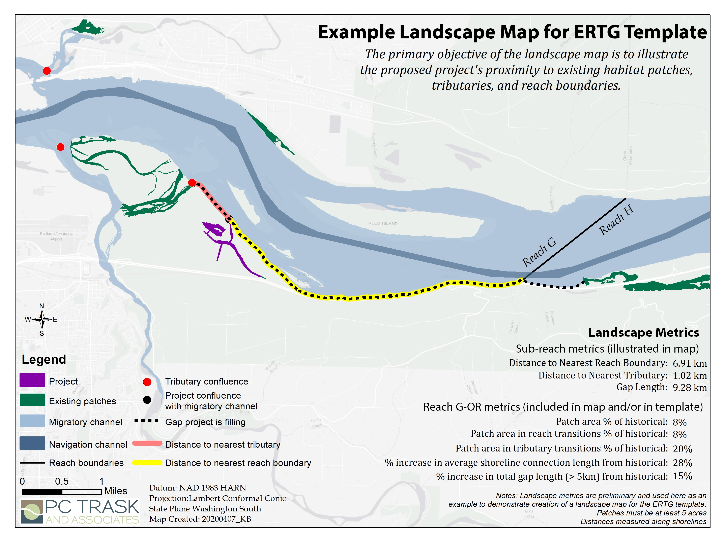
Example Project Goal Map (from ERTG #2020-01)

Controlling factors are the basic physical and chemical conditions that construct and influence the structure of the ecosystem.

